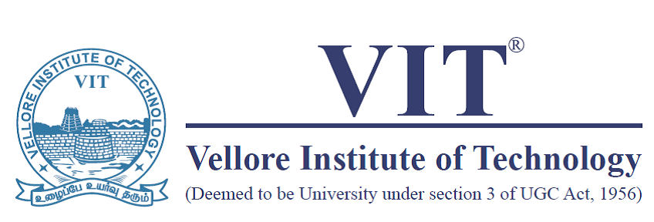
SCHOOL OF INFORMATION TECHNOLOGY AND ENGINEERING
M. Tech. (SE)/MS(SE) Master’s Thesis
Capstone Project – 0th Review

Register Number | 14MSE0325
Student Name | VINAY.R
Project Domain | Security
Project Title (Capstone Project) | Thumbsignin
Abstract* (100-150 Words) | Motivation:This system ensures that biometric authentication is done entirely on the user’s device, with no biometric data stored on a server.  Existing System uses conventional way of entering passwords and authentication details.  Pros of existing System:Simple to use,Simple to deploy  Cons of existing System:Does not provide strong identity check (only based on password).  Advantages of the proposed system.:Anti Phishing,User Secret Protection,Man In The Middle Attack proof,Replay Attack Proof.
Project Type: In-House only / Internship/ Internship through PAT | Internship Details  Company Name:Pramati Technologies  Company full Address:114, Rajiv Gandhi IT Expy, Phase-2, Thirumalai Nagar Annexe, Perungudi, Chennai, Tamil Nadu 600096  Period of Internship:8 months
Guide Name & Signature
Guide Approval
Date

